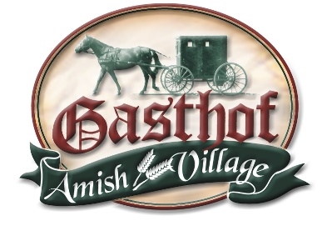
Gasthof Amish Village
Wedding Facilities & Services
Group Gathering Spaces
The Loft-
$1,000 rental
The Loft is a beautiful large open banquet room located on the second level above the Gasthof Restaurant. It accommodates up to 285 people, is Non-Smoking, and Elevator Accessible. You have access to the Loft from 8 am-midnight on the day of your rental. If you are not out by midnight, it is $100.00 for every hour past midnight. You have until noon the following day to come back in to get your decorations. You will also have access to the Loft the day before your event to decorate/set up tables.
Included in the rental: plastic plates, plastic silverware, plastic cups
Not Provided: decorations, table coverings, cake plates & forks, bar service, set up
You are in charge of getting a licensed bartender if you are having alcohol.
To add on additional days, it is $200.00/day for decorating or set up.

Large Banquet Building-
$800 rental
The Large Banquet Building is a spacious building that will accommodate up to 180 people. It is located separate from the hotel and restaurant, which allows us to give you 24-hour access to this building. It is ground level. You have until noon the following day to come back in to get your decorations. You will also have access to the Banquet Building the day before your event to decorate/set up tables.
Included in the rental: plastic plates, plastic silverware, plastic cups
Not Provided: decorations, table coverings, cake plates & forks, bar service, set up
You are in charge of getting a licensed bartender if you are having alcohol.
To add on additional days, it is $200.00/day for decorating or set up.

Gazebo or Lakeside Outdoor Wedding Ceremony Locations-
$400 rental if reception is at the Gasthof
$600 rental if ceremony only
The Gazebo or Lakeside locations are the perfect settings for outdoor wedding ceremonies. Outdoor Chair Rental is available. The white lawn chairs rent for $3.00 + tax per chair and includes set up and tear down.

Combo Rate- $1,700.00- Includes rental of the Loft & Large Banquet Building
Combo Rate- $2,100.00- Includes rental of the Loft, Large Banquet Building, & Gazebo or Lakeside
To add on additional days, it is $200.00/day for decorating or set up.

Gasthof Room-
$50- ½ day rental (4 hrs or less); $100- full day
The Gasthof Room is located on the main level of the Gasthof Restaurant. Groups using this room must dine from our buffet. This room accommodates up to 50 people classroom style or 80 people banquet style.

Rental Options-
Dance Floor- $250.00 Our portable dance floor is light oak in color, and we can vary the size based on space and need. The maximum size is 16x24 feet.
Tablecloths- $5.00 each White linen tablecloths

Pricing can vary, so please contact Tyra at 812-486-4900 or tyrafuhs@gasthofvlg.com to discuss!
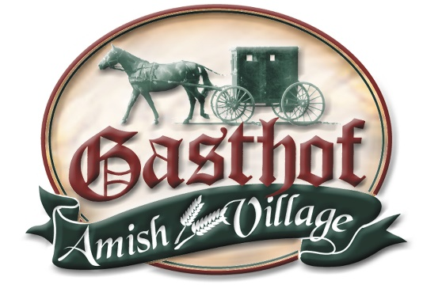
Gasthof Banquet Menu
Included in the price:
Assorted Cookies & Cupcakes
Homemade Breads, Apple Butter, Peanut Butter & Butter
Iced Tea, Sweet Tea, Lemonade & Water
Throw Away Cups, Plates, Napkins & Silverware

Option #1: Choice of 1 Meat & 3 Side Items $16.00 Meal + 18% gratuity + tax= $20.00 per person

Option #2: Choice of 2 Meats & 4 Side Items $17.50 Meal + 18% gratuity + tax= $21.88 per person

Option #3: Choice of 3 Meats & 5 Side Items $19.50 Meal + 18% gratuity + tax= $24.38 per person

Option #4: Choice of 4 Meats & 6 Side Items $22.00 Meal + 18% gratuity + tax= $27.50 per person

Prices listed above are for ages 6 years old and up, ages 0-5 years old are free.

Meat/Entrée Choices:

Roast Beef Fried Chicken Baked Ham Baked Chicken Fried Fish Smoked Pork Loin

Roast Turkey Pulled BBQ Pork Swiss Steak Baked Fish Beef & Noodles BBQ Pork Loin

BBQ Chicken Bourbon Chicken Meat Loaf Lasagna BBQ Ribs Grilled Chicken Breast

Side Items:

Sweet Potato w/ Marshmallow (sliced, baked w/ brown sugar) Peas & Carrots

Noodles California Blend w/ Cheese Scallop Potato Buttered Corn

Baked Beans Garlic Parmesan Red Potato Potato Salad Baked Potato

Broccoli Mashed Potato & Gravy Italian Pasta Salad Au Gratin Potato

German Fries Creamy Cole Slaw Honey Glazed Carrots Green Beans

Tossed Salad Homemade Dressing

If there is something you would like at your event that is not listed, just ask!

We want to create the perfect menu for you… and we are OPEN 7 DAYS A WEEK!

For more information or if you have questions please contact: Tyra Fuhs- Events Coordinator

812-486-4900 tyrafuhs@gasthofvlg.com 6747 Gasthof Village Rd Montgomery, IN 47558

