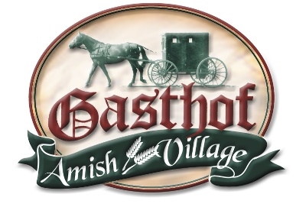
Gasthof Amish Village
Wedding Facilities & Services
Group Gathering Spaces
The Barn-
$2,900 rental
The Barn at Gasthof is a gorgeous rustic barn that includes modern amenities. Adorned with decor and rustic touches, it seats up to 300 people, has heating and air conditioning, and includes a bride’s and groom’s room. Also included are beautiful restrooms and white tables & chairs for your guests. With your rental, you have access to The Barn from 8:00 am on the day prior to your event until 12:00 noon the day following your event to come back to get your decorations.
The Barn is also available for Parties & Meetings at the following rates:
$500- ½ day rental (4 hrs or less) + $200 refundable damage deposit
$800- 1 day rental (8 hrs or less) + $200 refundable damage deposit

The Loft-
$1,000 rental
The Loft is a beautiful large open banquet room located on the second level above the Gasthof Restaurant. It accommodates up to 285 people, is Non-Smoking, and Elevator Accessible. You have access to the Loft from 8:00 am-midnight on the day of your rental. If you are not out by midnight, it is $100.00 for every hour past midnight. You have until noon the following day to come back in to get your decorations. You will also have access to the Loft the day before your event to decorate/set up tables.
To add on additional days, it is $200.00/day for decorating or set up.

Large Banquet Building-
$800 rental
The Large Banquet Building is a spacious building that will accommodate up to 180 people. It is located separate from the hotel and restaurant, which allows us to give you 24-hour access to this building. It is ground level. You have until noon the following day to come back in to get your decorations. You will also have access to the Banquet Building the day before your event to decorate/set up tables.
To add on additional days, it is $200.00/day for decorating or set up.

Gazebo or Lakeside Outdoor Wedding Ceremony Locations-
$200 rental if reception is at the Gasthof
$400 rental if ceremony only
The Gazebo or Lakeside locations are the perfect settings for outdoor wedding ceremonies. Outdoor Chair Rental is available. The white lawn chairs rent for $2.00 + tax per chair and includes set up and tear down.

Combo Rate- $1,700.00- Includes rental of the Loft & Large Banquet Building
Combo Rate- $1,900.00- Includes rental of the Loft, Large Banquet Building, & Gazebo or Lakeside
To add on additional days, it is $200.00/day for decorating or set up.

Gasthof Room-
$50- ½ day rental (4 hrs or less); $100- full day
The Gasthof Room is located on the main level of the Gasthof Restaurant. Groups using this room must dine from our buffet. This room accommodates up to 50 people classroom style or 80 people banquet style.

Rental Options & Notes-
Dance Floor- $250.00 Our portable dance floor is light oak in color, and we can vary the size based on space and need. The maximum size is 16x24 feet and may be used in The Loft or Large Banquet Building.
Tablecloths- $5.00 each White linen tablecloths
Not Provided with rentals: decorations, table coverings, cake plates & forks, bar service, set up
You are in charge of getting a licensed bartender through a business with a liquor license if you are having alcohol.

Pricing can vary, so please contact Tyra at 812-486-4900 or tyrafuhs@gasthofvlg.com to discuss!

